UR5 Robotic Arm – Inverse Kinematics Verification Tool

Mini Project / Assignment Problem Statement

Task 1: DH Parameter Modelling
Denavit-Hartenberg (DH) Modelling is a standardized mathematical framework used in robotics to describe the geometry of a robotic manipulator's links and joints. To calculate where the end of the robot is relative to the base.
Instead of needing six independent variables (three for translation and three for rotation) to describe the relationship between every single pair of adjacent joints, the DH convention minimizes this complexity. It proves that any spatial relationship between two consecutive joint axes can be completely defined using only four parameters
Step 1: Set the axis along movement axis of joints. As given Z axis in figure.
Step 2: Set the origin.
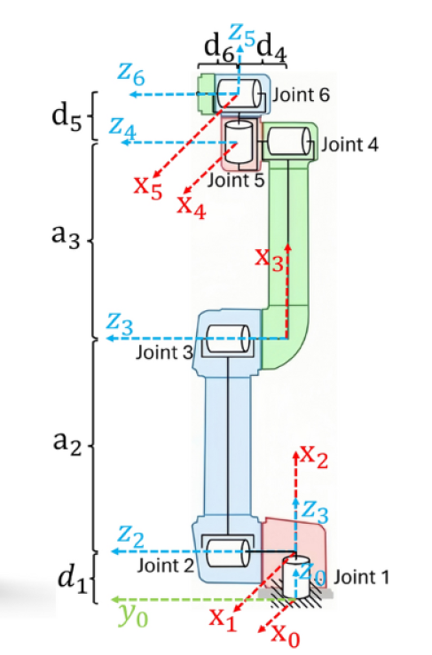

Origin

Four DH Parameters:
- a_{i-1} = Distance from Z_{i} to Z_{i+1} measured along X_{i} - Link Length
- α_{i-1} = Angle from Z_{i} to Z_{i+1} measure about X_{i} - Link Twist
- d_{i} = Distance from X_{i-1} to X_{i} measure along Z_{i} - Link offset
- θ_{i} = Angle from X_{i-1} to X_{i} measured about Z_{i} - Joint angle
Given a joint vector (q = [q_1, q_2, q_3, q_4, q_5, q_6])
Axis | a_{i-1} | α_{i-1} | d_{i} | θ_{i}
Z₀ - Z₁ | 0 | 0 | d1 | q1
Z₁ - Z₂ | 0 | π/2 | 0 | q2
Z₂ – Z₃ | a2 | 0 | 0 | q3
Z₃ – Z₄ | a3 | 0 | d4 | q4
Z₄ – Z₅ | 0 | - π/2 | d5 | q5
Z₅ – Z₆ | 0 | π/2 | d6 | q6
(DH Parameter Modelling Table)
Individual Transformation matrices:
According to :
$${}_{}^{i-1}{T_{i}}=\left[\begin{matrix}{\cos{θ}}_{i} & -{\sin{θ}}_{i} & 0 & a_{i-1} \\ {\sin{θ}}_{i}{\cos{α}}_{i-1} & {\cos{θ}}_{i}{\cos{α}}_{i-1} & -{\sin{α}}_{i-1} & -d_{i}{\sin{α}}_{i-1} \\ {\sin{θ}}_{i}{\sin{α}}_{i-1} & {\cos{θ}}_{i}{\sin{α}}_{i-1} & {\cos{α}}_{i-1} & d_{i}{\cos{α}}_{i-1} \\ 0 & 0 & 0 & 1\end{matrix}\right]$$

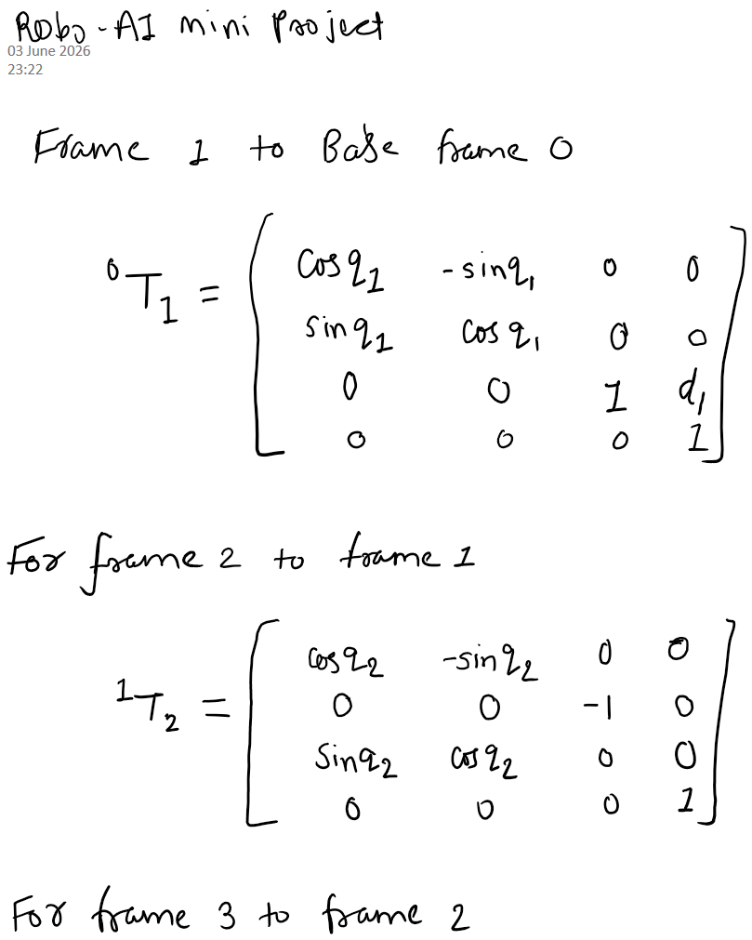
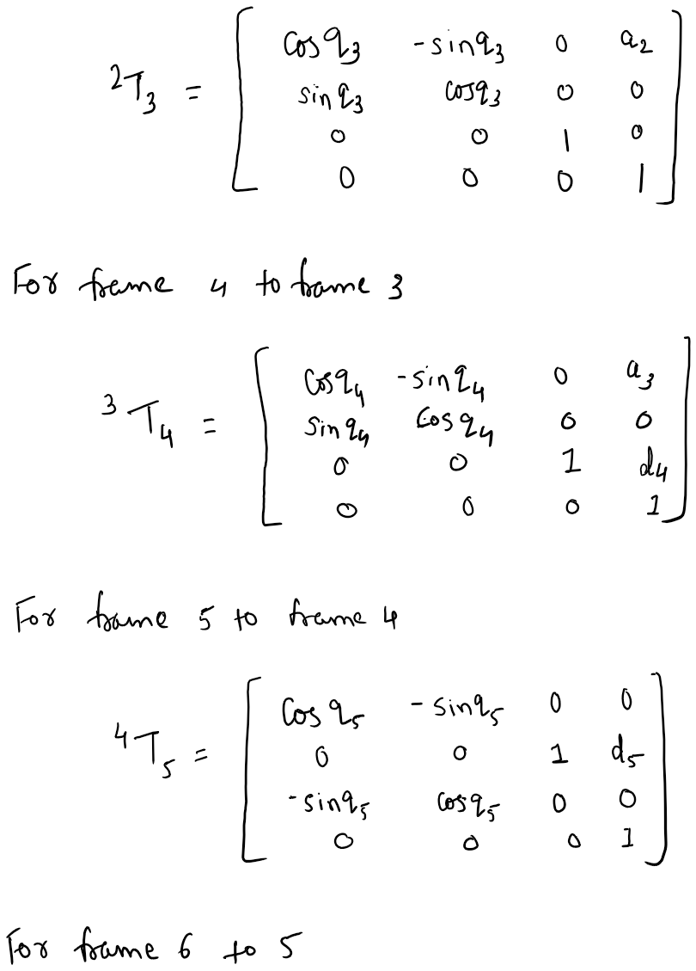
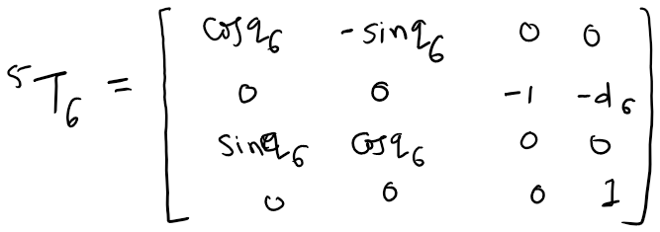

Task 2: Forward Kinematics

Here we have to find overall transformation from base to end effector position.
Over all transformation is .
- $⋅$ (dot) represent matrix multiplication
$$0T_{6}=0T_{1}⋅1T_{2}⋅2T_{3}⋅3T_{4}⋅4T_{5}⋅5T_{6}$$

Applied using python by considering parameters as below:
d1 = 0.089159
a2 = -0.425
a3 = -0.39225
d4 = 0.10915
d5 = 0.09465
d6 = 0.0823
and q = [0.0, 0.0, 0.0, 0.0, 0.0, 0.0]
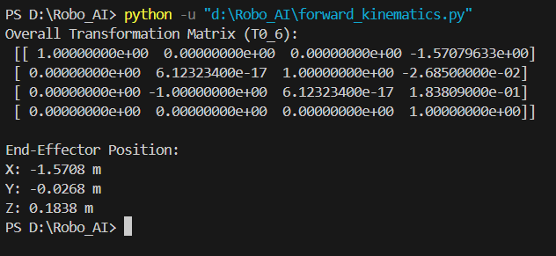

Task 3: Inverse Kinematics (Numerical)
Here used an iterative numerical Inverse Kinematics approach and utilizing the Newton-Raphson method and the Moore-Penrose pseudo-inverse Jacobian was implemented. The numerical method was chosen to guarantee algorithmic stability, enable robust error minimization across the full 6-DoF pose, and seamlessly integrate the singularity identification requirements outlined in the problem statement.
We can find it using Jacobian, derived using Newton Raphson Method:
$$Δx=J\left(q\right)Δq$$

To isolate and solve for the joint angle update vector $Δq$ . we invert the Jacobian matrix. To prevent calculation failures at or near kinematic workspace boundaries and alignment traps, the Moore-Penrose pseudo-inverse $J^{†}$ is computed via Singular Value Decomposition (SVD):
$$Δq=J^{†}⋅Δx$$
The joint vector is then updated iteratively:

$$q_{new}=q_{current}+Δq$$

Task 4: IK Verification Pipeline

To robustly validate the integrity of the Inverse Kinematics solution framework, a closed-loop forward-to-inverse pipeline was structured as follows:
- Ground Truth Generation: Define a known arbitrary target joint vector configuration.
- Target Pose Generation: Pass ground truth through the verified Forward Kinematics engine to compute an exact target homogeneous matrix T_{desired}.
- IK Execution Test: Strip away the joint angle knowledge, feed only $T_{desired}$ into the Inverse Kinematics solver loop, and calculate the resulting joint configuration solution q_{calculated}.
- Error Convergence Evaluation: Run q_{calculated} back through Forward Kinematics to secure a verified pose matrix T_{verified}, and evaluate the absolute discrepancy matrix gap relative to $T_{desired}$.
$$\text{Absolute Evaluation Error}={\left\|T_{desired}-T_{verified}\right\|}_{F}$$
An optimization run is classified as a Valid IK Solution if and only if the total residual Frobenius norm error falls below an acceptable industrial tolerance threshold of 10⁻⁵

Results
